

Tamey Gail Crotty Wolfe, John's wife - 6 Sept 2008

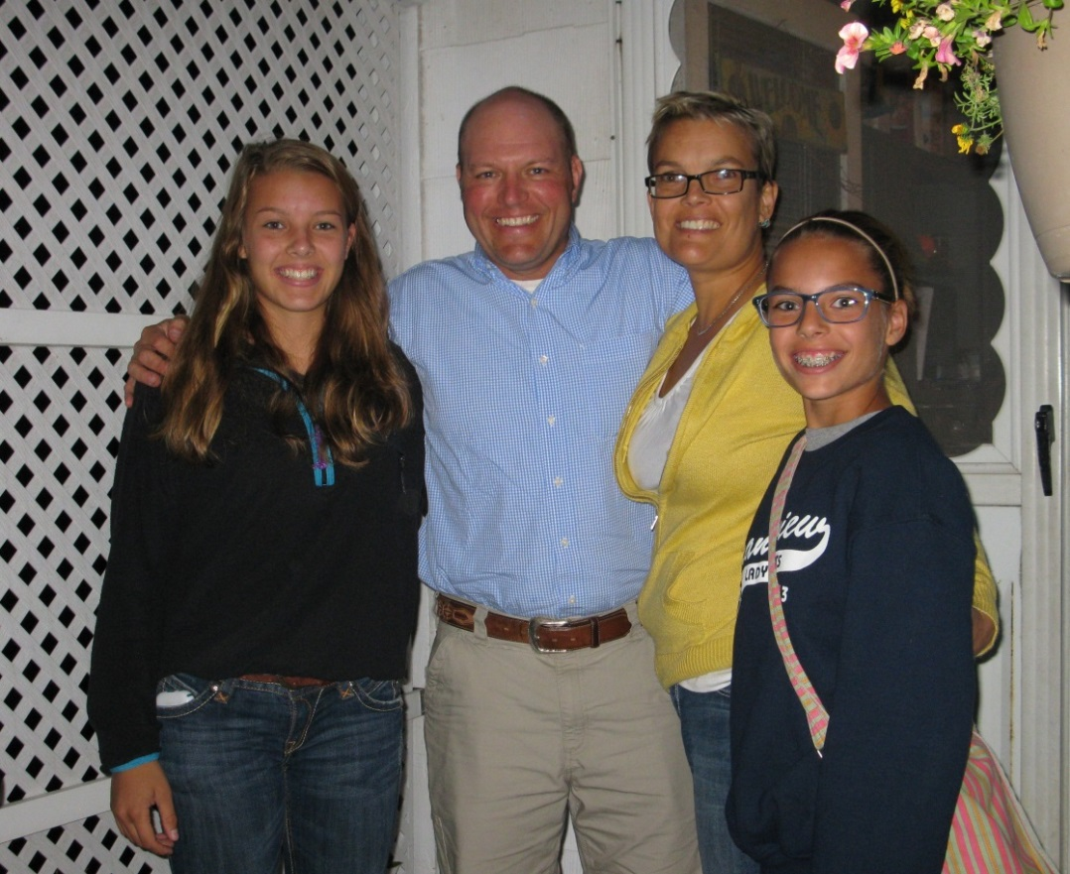

Tyler & Laura Wolfe family Erin & Leah – 2013